HYDRAULIC AND ELECTRICAL SCHEMATICS
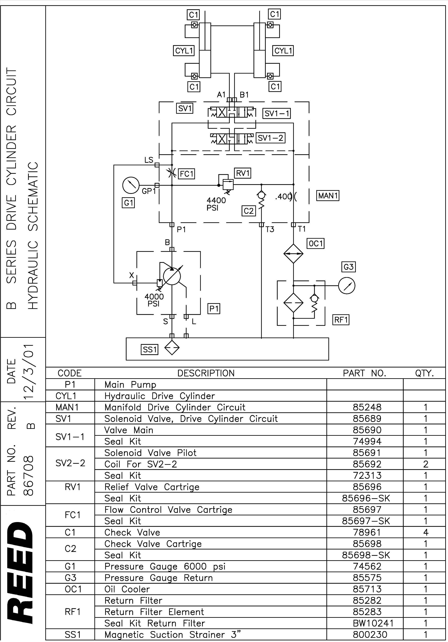
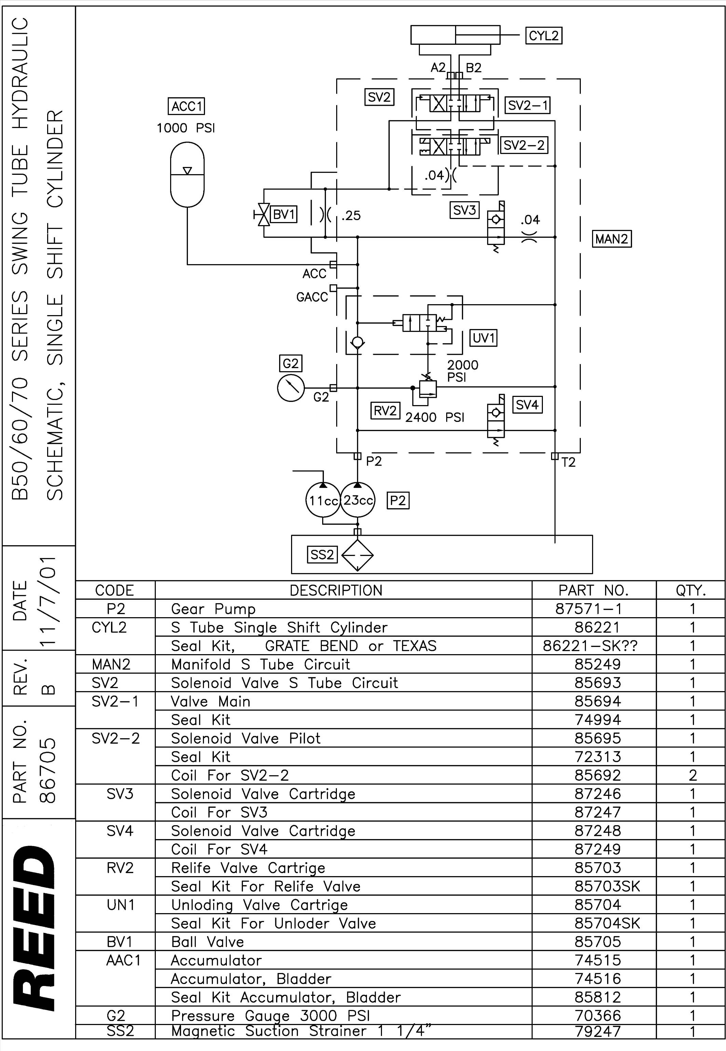
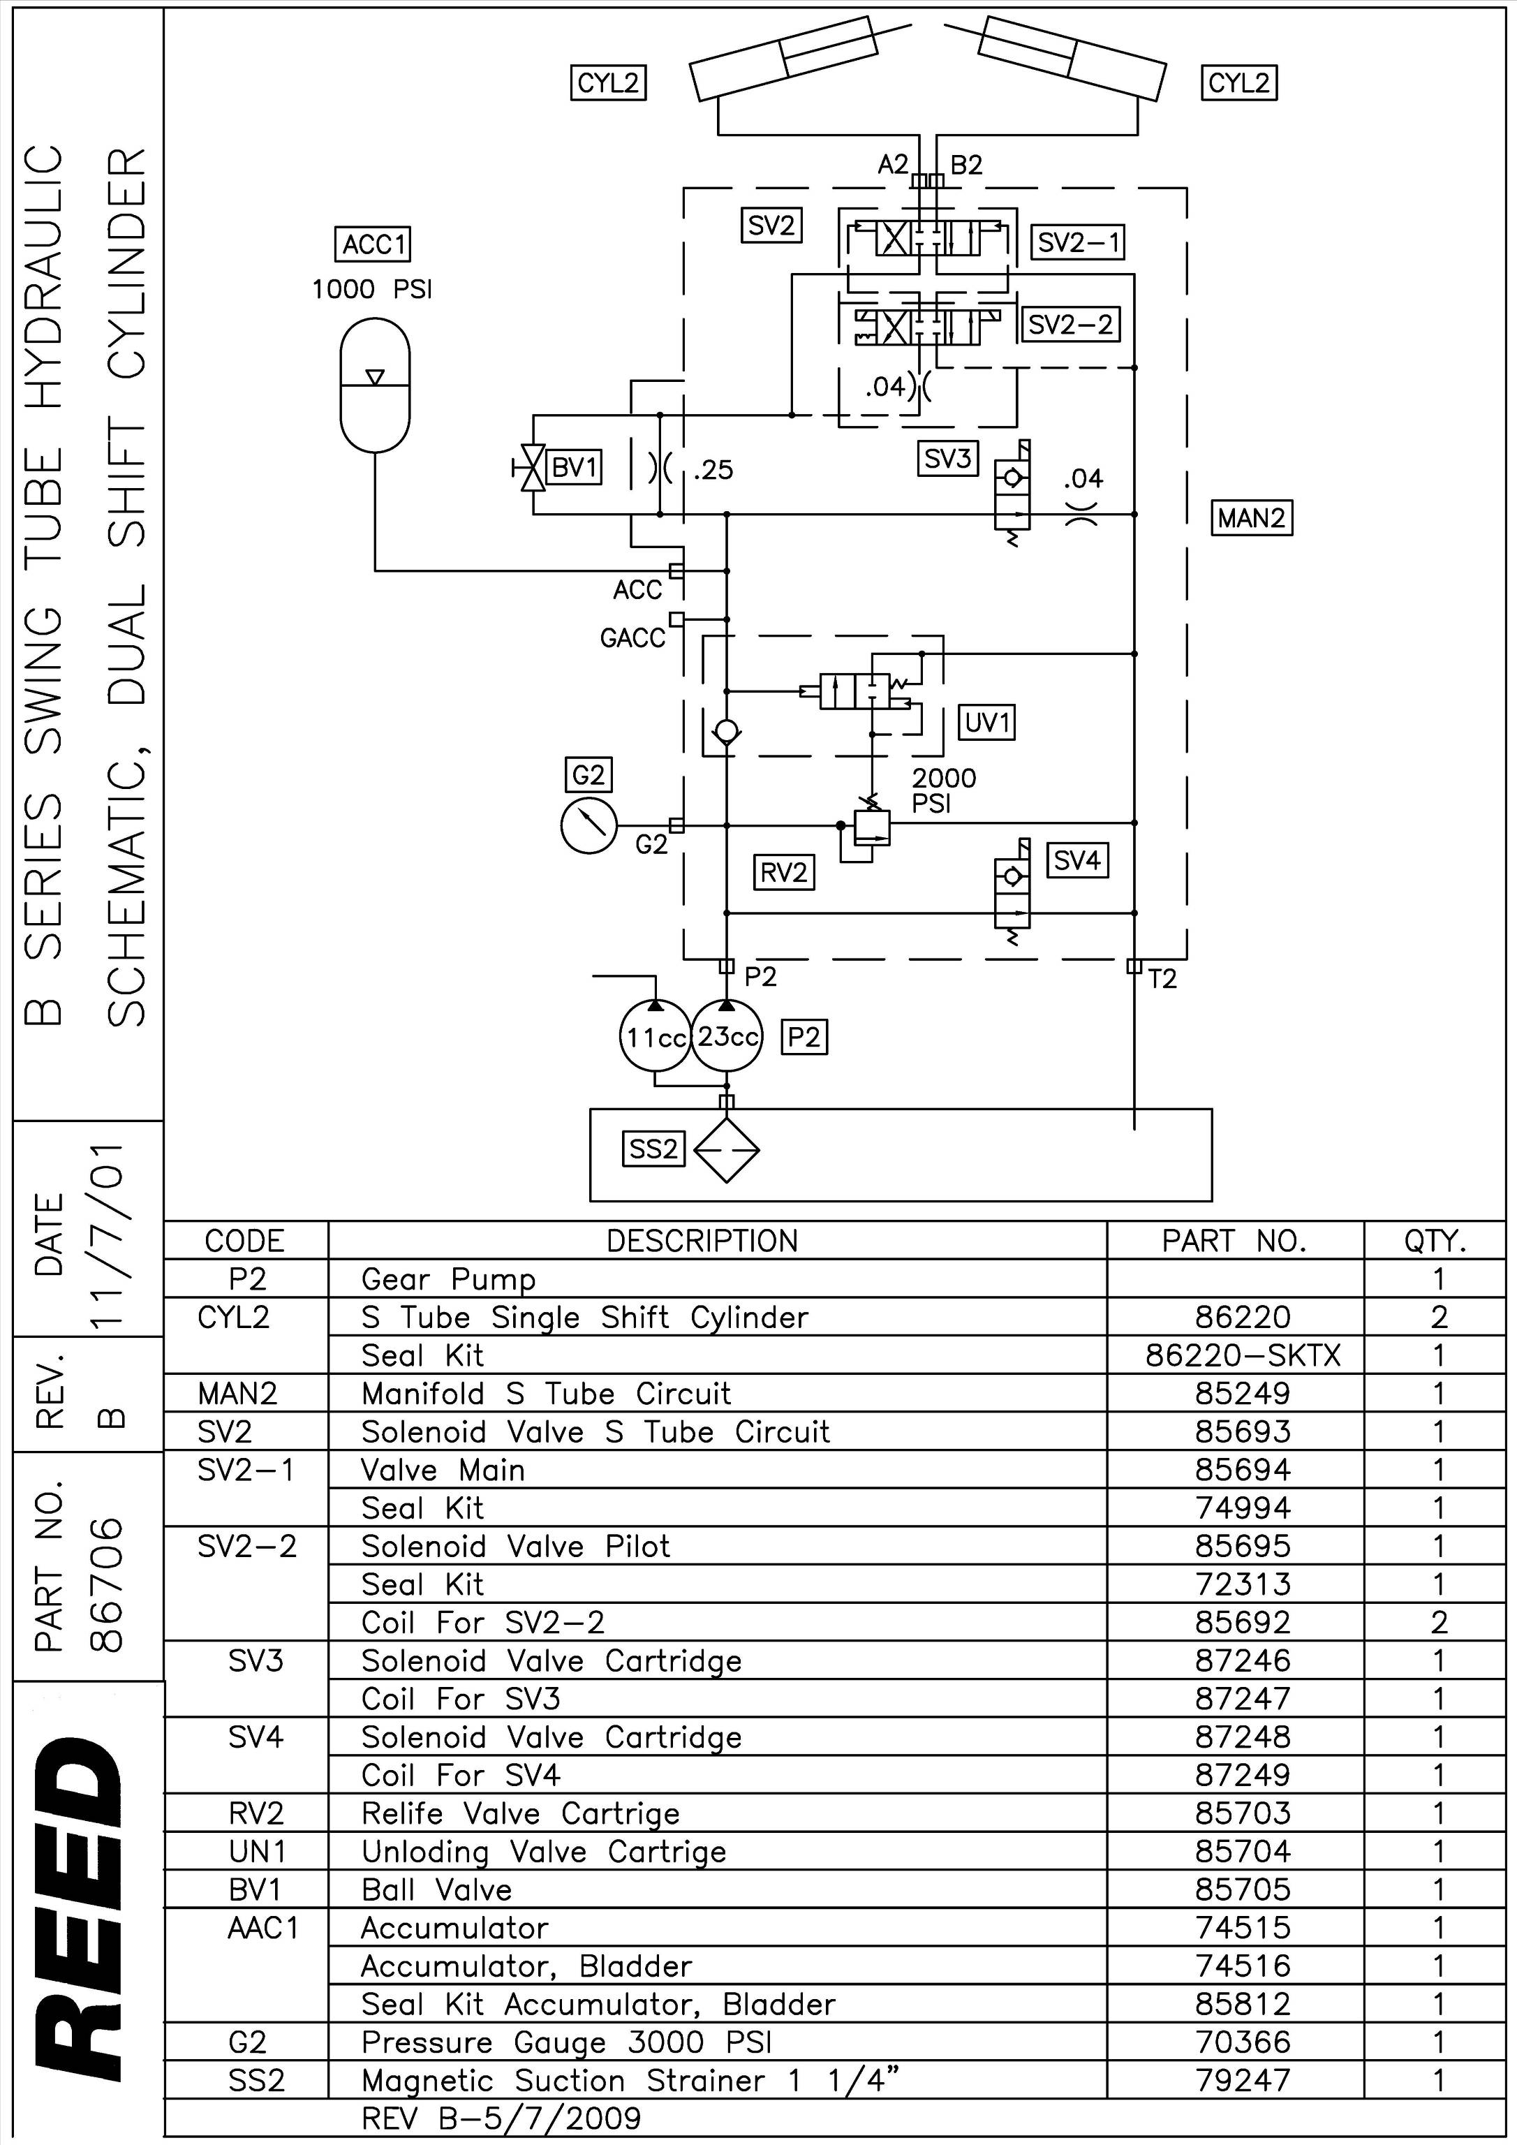
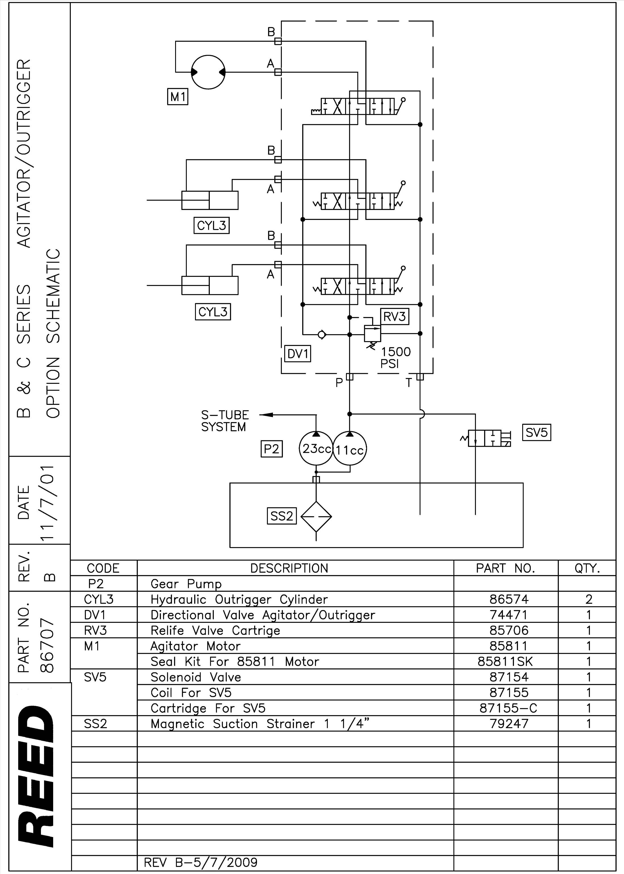
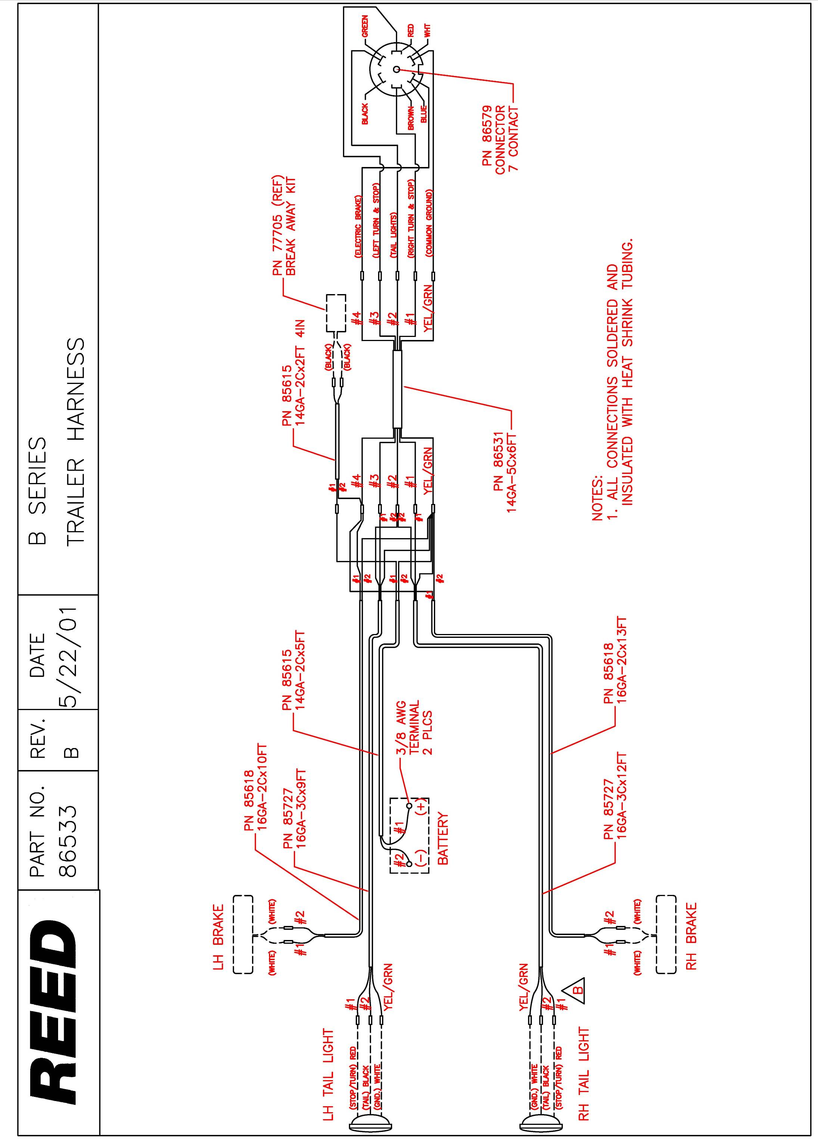
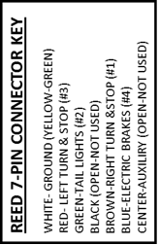

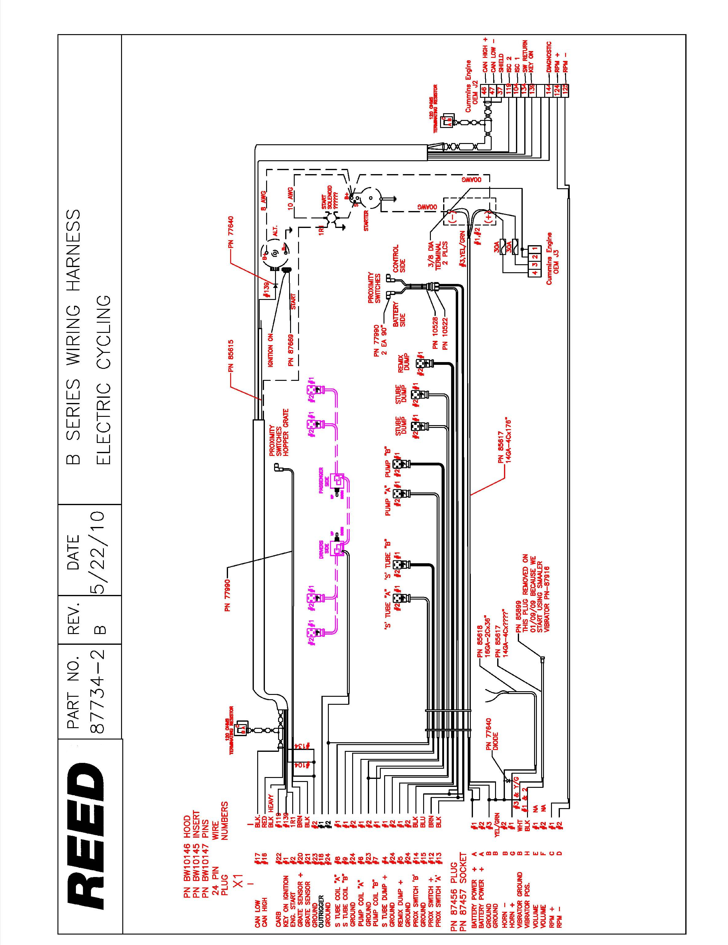

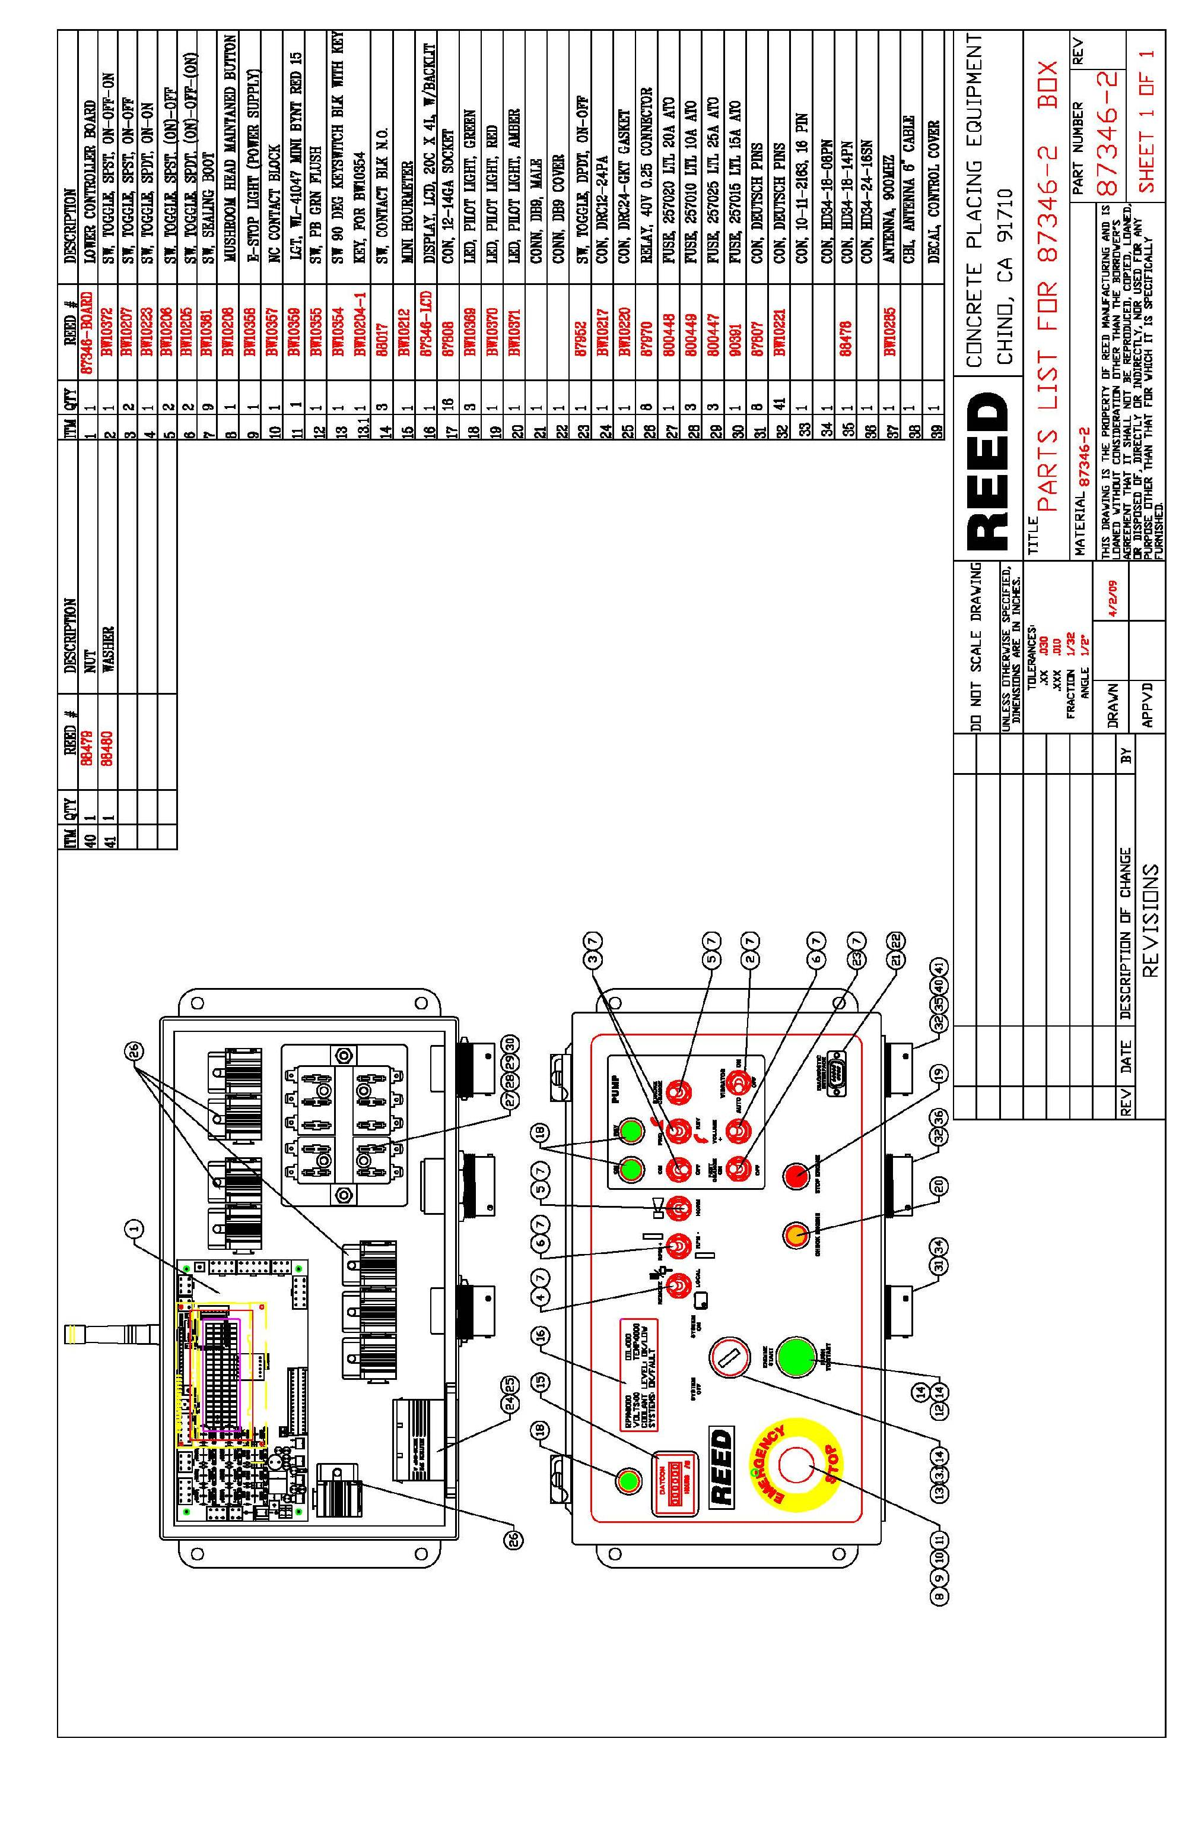
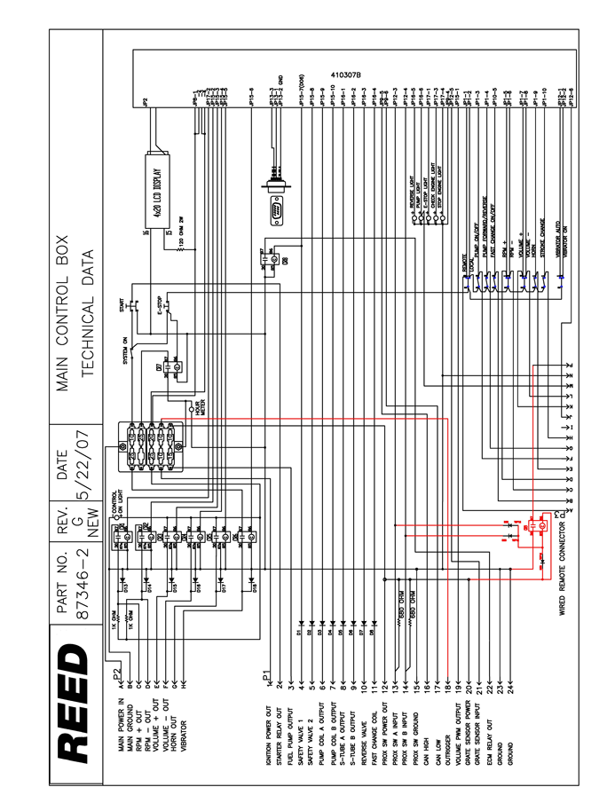
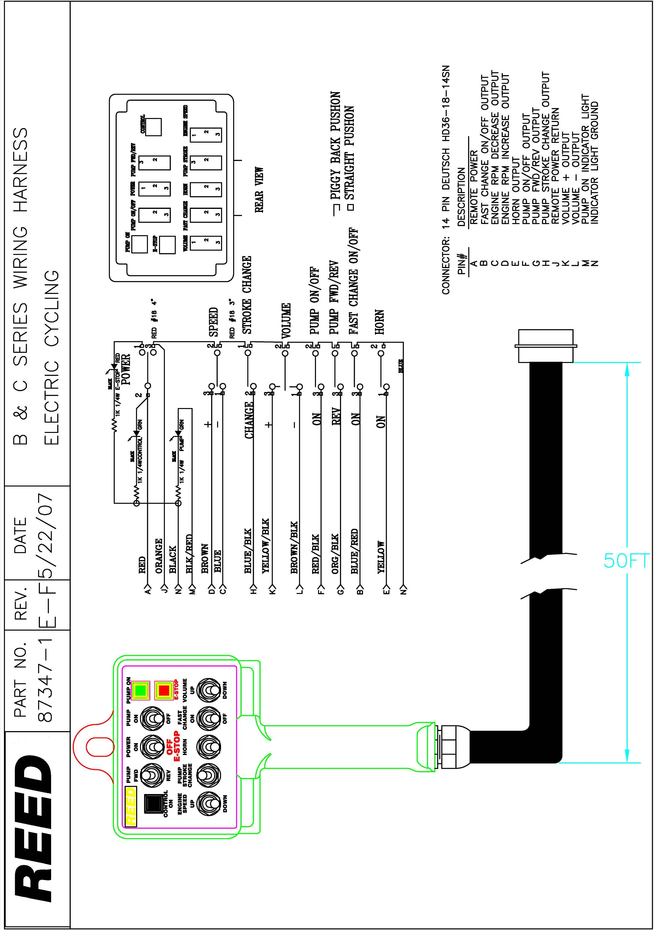
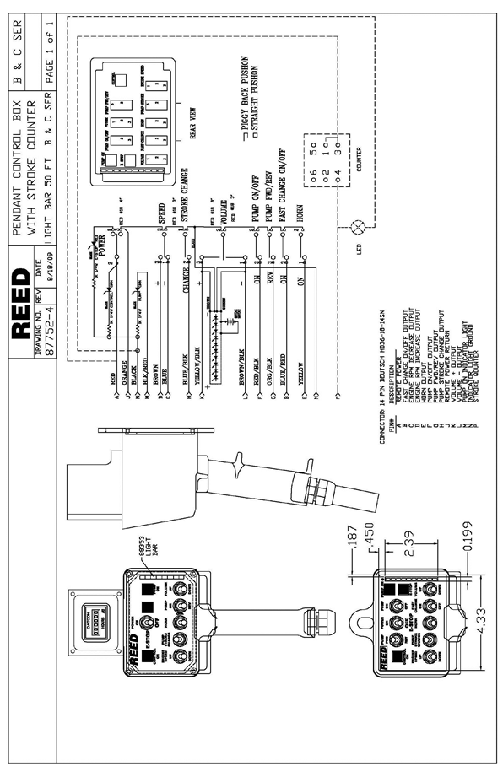
Cummins Error Codes
Code & descriptions

EC01 – No radio link (no signal from either radio or cable)
EC02 – J1939 CAN link error
EC03 – RPM Plus
EC04 – RPM Minus
EC05 – Volume Plus
EC06 – Volume Minus
EC07 – Horn
EC08 – Vibrator
EC09 – Safety Valve 1
EC10 – Safety Valve 2
EC11 – Pump Coil A
EC12 – Pump Coil B
EC13 – S Tube A
EC14 – S Tube B
EC15 – Reverse Coil Output – enabled when calibration checkbox for Reverse Logic Change is unchecked.
EC16 – Fast Change – enabled when the calibration checkbox for Fast Change is checked.
EC17 – Reverse Light out Error
EC18 – Pump Light Out Error
EC19 – Check Engine Light
EC20 – Stop Engine Light
EC21 – Volume PWM Output Error
EC22 – Prox A&B Error
EC23 – Wrong ID
EC24 – Engine RPM Overspeed
EC25 – Oil Low Pressure
EC26 – Coolant Over Temp.
EC27 – Low Batt. Voltage
EC28 – High Batt. Voltage
EC29 – Denison Fast Change
EC30 – Denison A (only on C series with Denison Hydraulic pumps)
EC31 – Denison B (only on C series with Denison Hydraulic pumps)

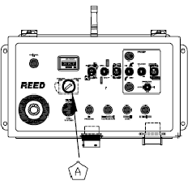
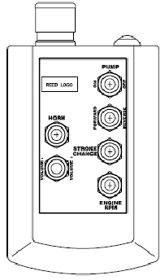
START HERE

TRANSMITTER RF. I.D
TEACH PRODUCE

STEP 1

TURN OFF RADIO FIRST BY PUSHING AND HOLDING THE POWER BUTTON ON THE TOP OF THE TRANSMITTER.

NOTE: IF THE TRANSMITTER IS STILL ON
THE GREEN LED WILL LIGHT WHEN ANY SWITCH OTHER THAN THE POWER BUTTON IS PRESSED.
TRANSMITTER
CONTROL BOX
STEP 2

PRESS AND HOLD PUMP ON, RPM+, STROKE CHANGE, AND REVERSE SIMULATANEOSLY. WHILE HOLDING THESE FOUR SWITCHES, TURN THE RADIO ON BY PRESSING THE POWER BUTTON.
THEN RELEASE ALL SWITCH
RETURN PUMP ON/OFF SWITCH TO OFF AND FWD/REV SWITCH TO FORWARD.
THE RED AND GREEN LED’S SHOULD FLASH ALTERNATLY.
RADIO REMOTE PROGRAMING INSTRUCTIONS

CONTROL BOX SET-UP

STEP 3

TURN ON IGNITION KEY

NOTE: ENGINE DOES NOT NEED TO BE STARTED
STEP 4

THE TWO LED’S ON THE TRANSMITTER WILL STOP ALTERNATELY FLASHING. WILL COME ON STEADY TOGETHER FOR A FEW SECONDS AND THEN GO OFF WHEN THE TRANSMITTER AND RECIEVER ARE CORRECTLY SET UP FOR COMMUNICATION.
SET THE CONTROL BOX TO “REMOTE” AND IF THE CONTROL BOX DOES NOT SUCCESSFULLY RECEIVE COMMANDS FROM THE TRANSMITTER.
REPEAT THE PROCEDURE FROM STEP 1.

