HYDRAULIC AND ELECTRICAL SCHEMATICS
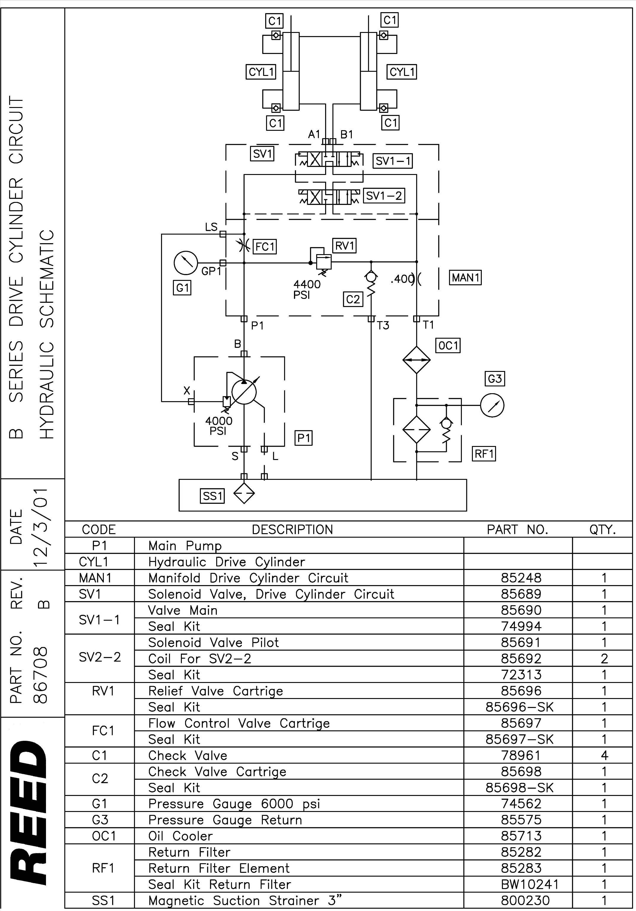
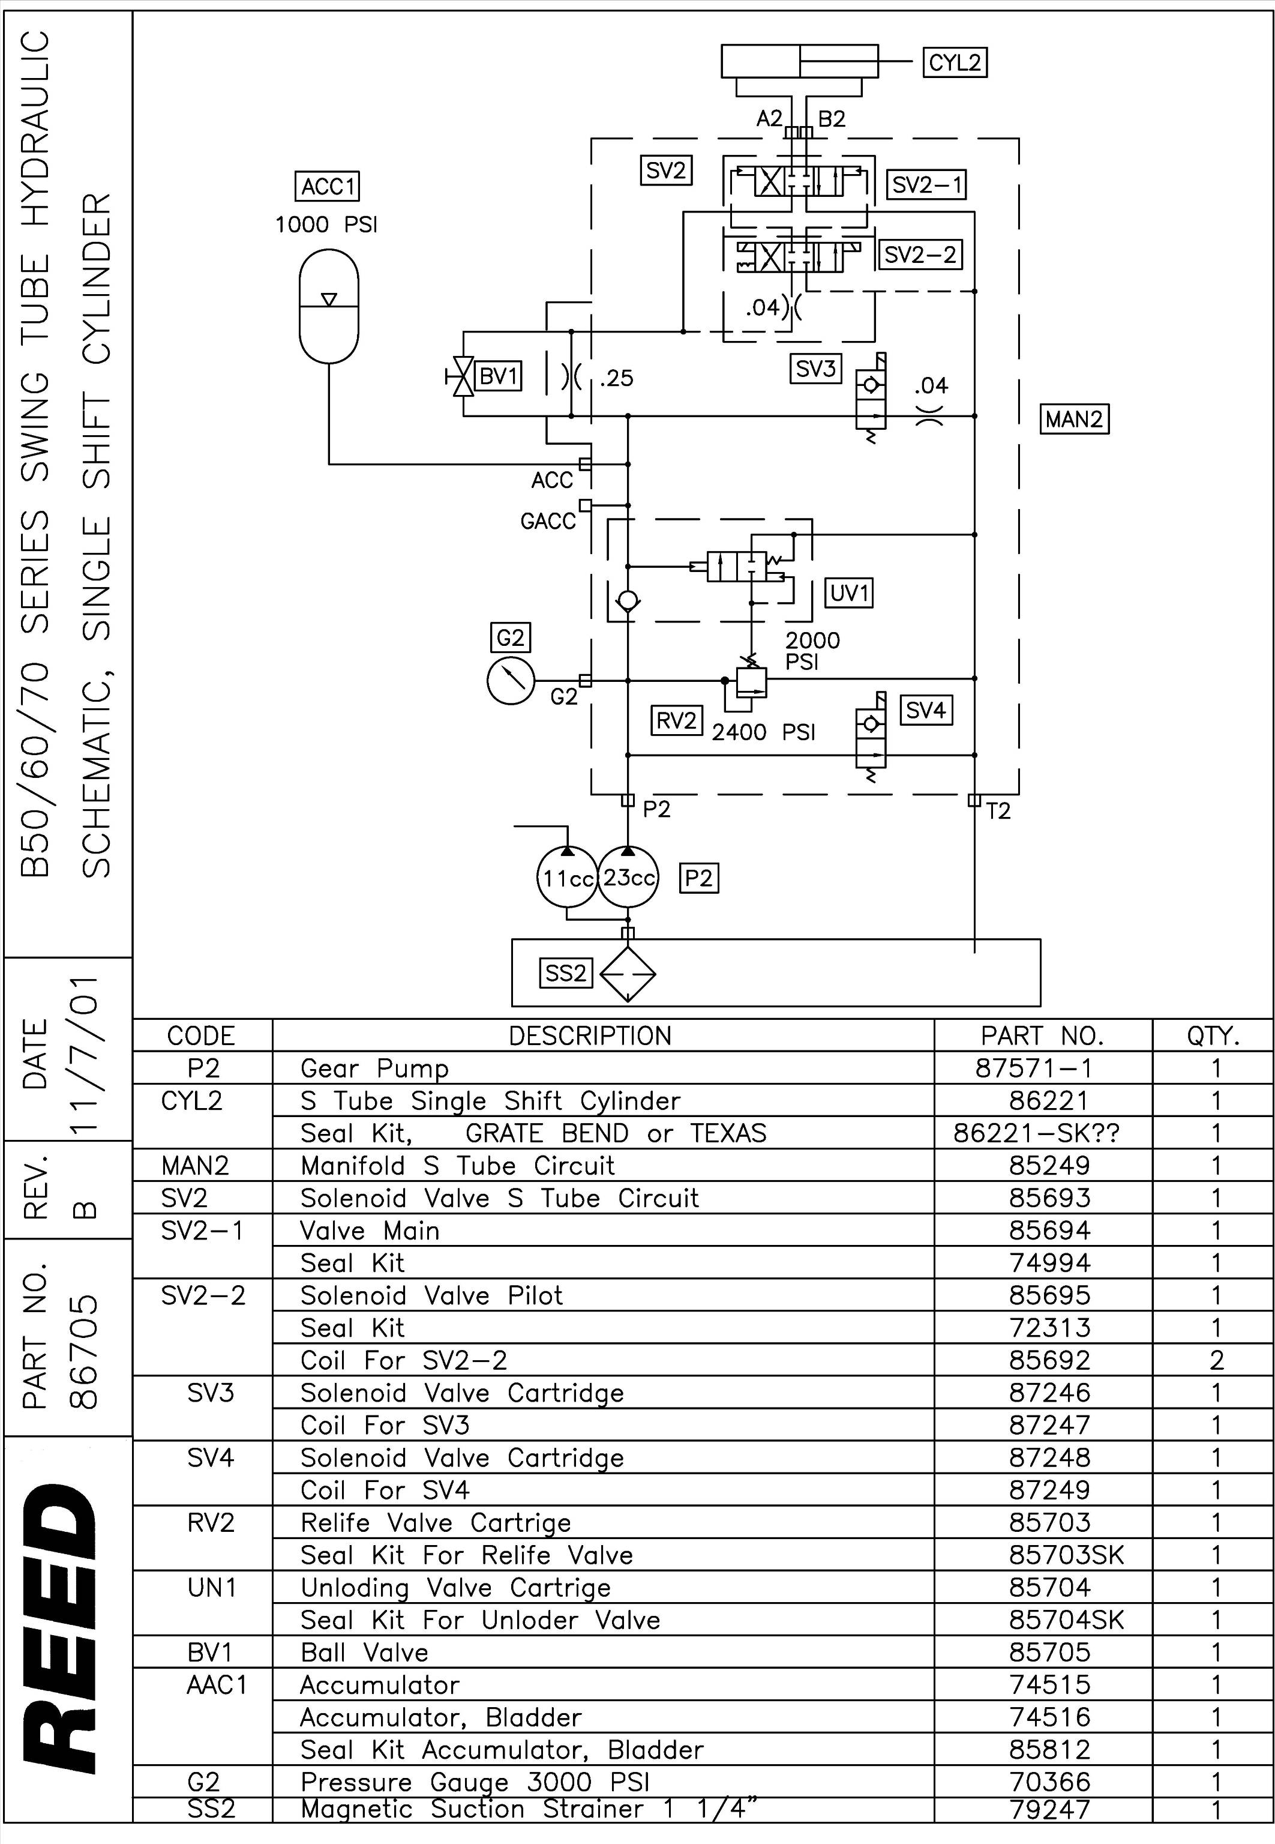

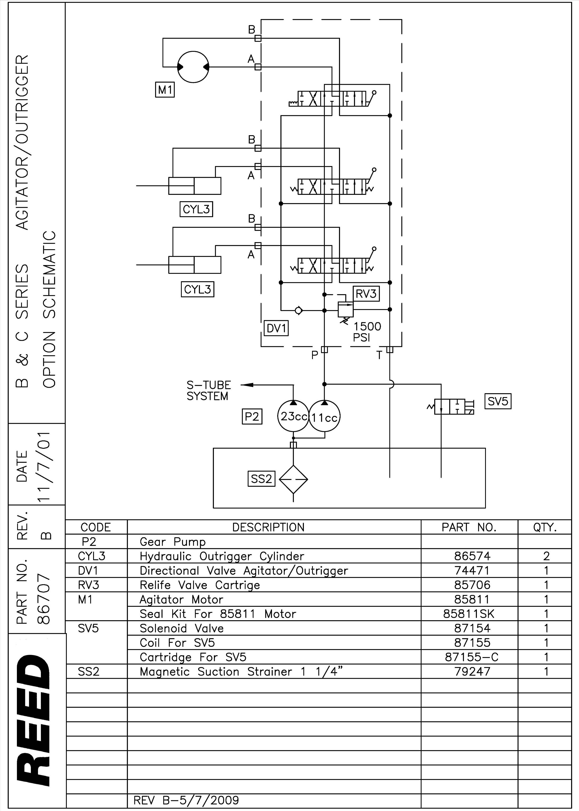

Controller Error Codes
Code & descriptions

EC01 – No radio link (no signal from either radio or cable)
EC02 – J1939 CAN link error
EC03 – RPM Plus
EC04 – RPM Minus
EC05 – Volume Plus
EC06 – Volume Minus
EC07 – Horn
EC08 – Vibrator
EC09 – Safety Valve 1
EC10 – Safety Valve 2
EC11 – Pump Coil A
EC12 – Pump Coil B
EC13 – S Tube A
EC14 – S Tube B
EC15 – Reverse Coil Output – enabled when calibration checkbox for Reverse Logic Change is unchecked.
EC16 – Fast Change – enabled when the calibration checkbox for Fast Change is checked.
EC17 – Reverse Light out Error
EC18 – Pump Light Out Error
EC19 – Check Engine Light
EC20 – Stop Engine Light
EC21 – Volume PWM Output Error
EC22 – Prox A&B Error
EC23 – Wrong ID
EC24 – Engine RPM Overspeed
EC25 – Oil Low Pressure
EC26 – Coolant Over Temp.
EC27 – Low Batt. Voltage
EC28 – High Batt. Voltage
EC29 – Denison Fast Change
EC30 – Denison A (only on C series with Denison Hydraulic pumps)
EC31 – Denison B (only on C series with Denison Hydraulic pumps)

